COSC 4351 Spring 2016
TEAM4OARS Team Project Acceptance Testing

--------------------------------------------------------------------------------------------------------

DBA
A
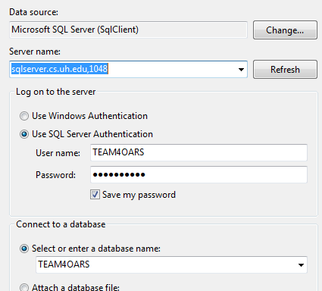
SCREENSHOT before:



1. DBA Login to TEAM?OARS DATABASE

SCREENSHOT after:
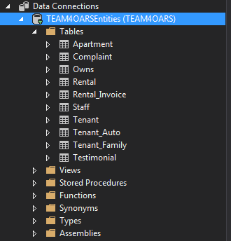

--------------------------------------------------------------------------------------------------------

SCREENSHOT before:
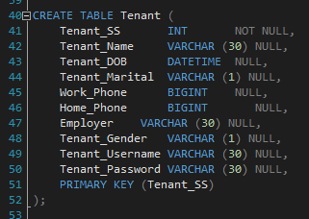
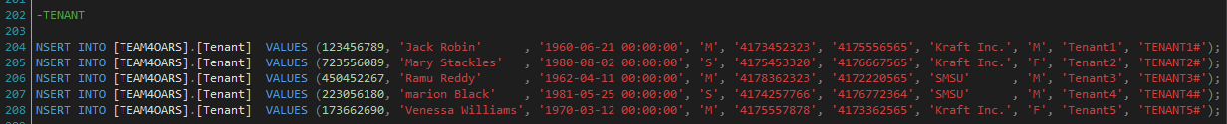
2. DBA DISPLAYS the contents of the TENANT TABLE. (5 tuples; 10 columns)

SCREENSHOT after:
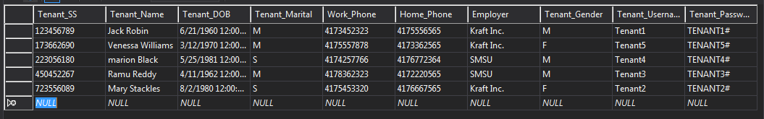
--------------------------------------------------------------------------------------------------------

SCREENSHOT before:
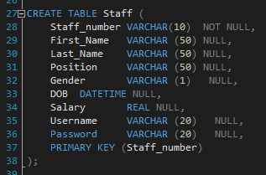
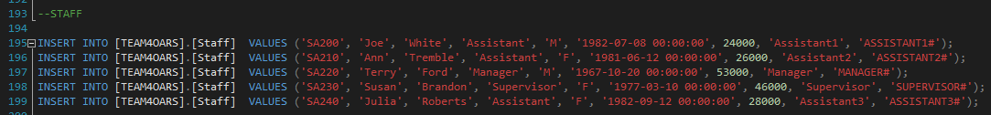
3. DBA DISPLAYS the contents of the STAFF TABLE. (5 tuples; 9 columns)

SCREENSHOT after:
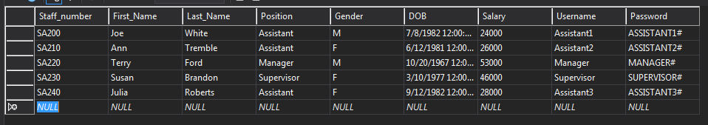
--------------------------------------------------------------------------------------------------------

SCREENSHOT before:
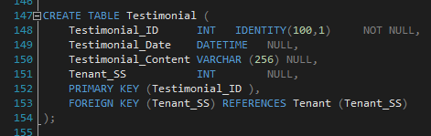
4. DBA DISPLAYS the contents of the TESTIMONIAL TABLE. (3 tuples; 4 columns)

SCREENSHOT after:
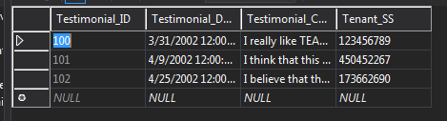
--------------------------------------------------------------------------------------------------------

Visitor & Customer Service/Assistant3
B

SCREENSHOT before:
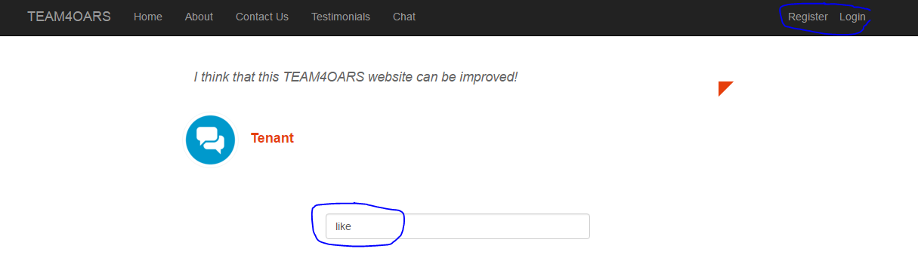

1. Visitor Search TESTIMONIALS for keyword “like”
SCREENSHOT after:
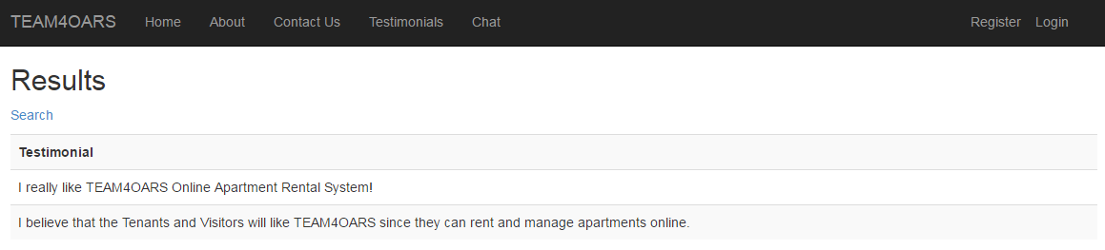

SCREENSHOT before:
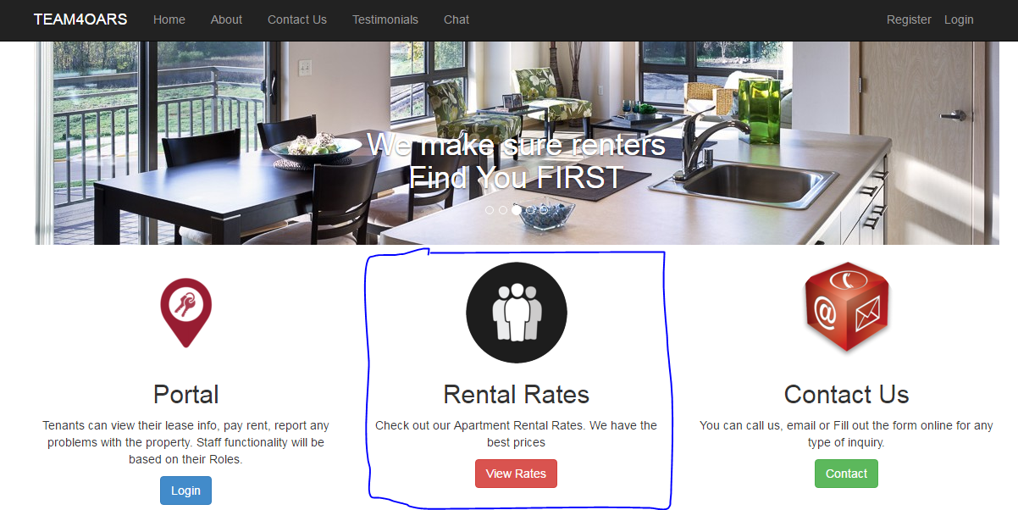

2. Is the Apartment Rental Rates, Type and Amount displayed on the page?

SCREENSHOT after:

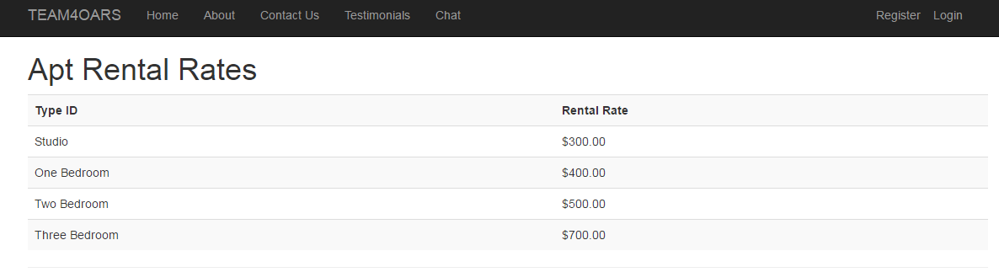

--------------------------------------------------------------------------------------------------------

SCREENSHOT before:
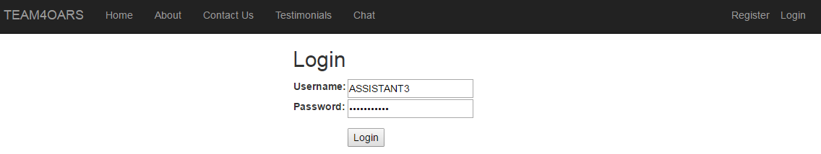

3. Customer Service –Login to TEAM4OARS (this account exists BEFORE A.T.)
ASSISTANT3 ASSISTANT3#

4. Is the ASSISTANT3 name and role displayed on the page? YES
SCREENSHOT after:
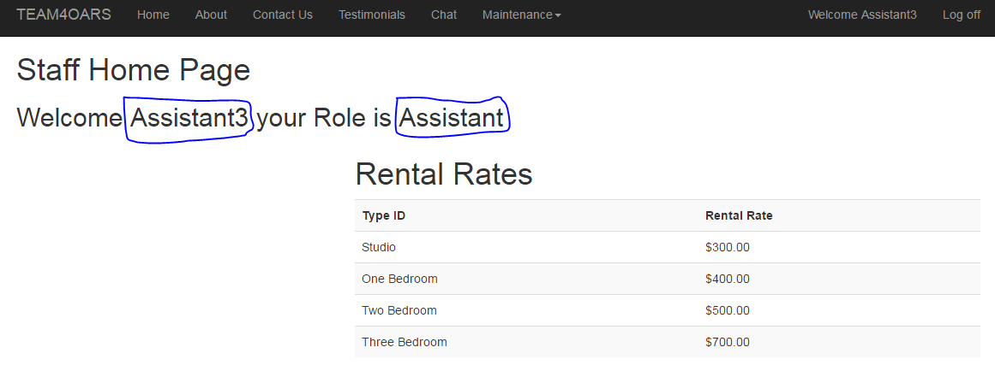

--------------------------------------------------------------------------------------------------------

SCREENSHOT before:

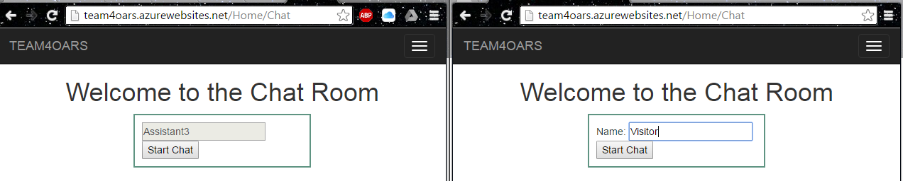

5. Visitor CHATS with Customer Service

SCREENSHOT after:
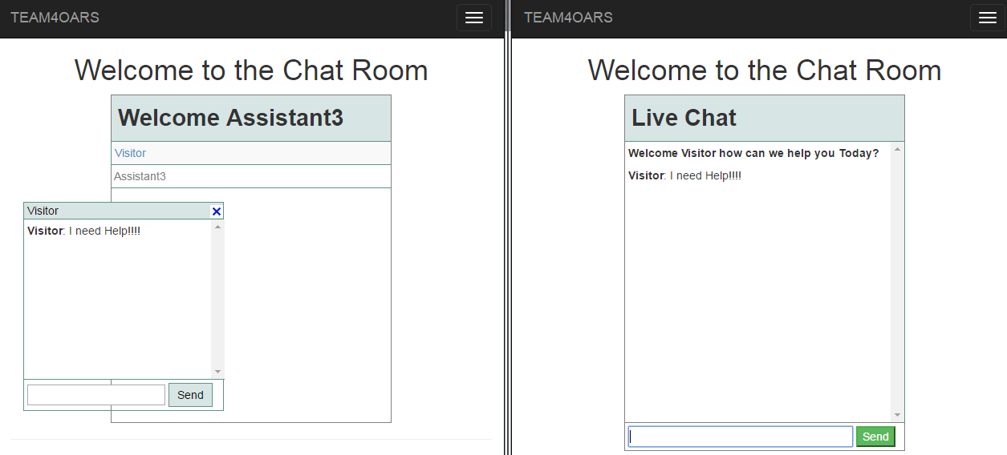
--------------------------------------------------------------------------------------------------------
Manager
C

SCREENSHOT before:

1. Login to TEAM4OARS (this account exists BEFORE A.T.)
MANAGER MANAGER#

2. Is the MANAGER name and role displayed on the page?

3. Is the Apartment Rental Rates, Type and Amount displayed on the page?

SCREENSHOT after:

--------------------------------------------------------------------------------------------------------

SCREENSHOT before:

4. List the APT NO of each apartment that is currently vacant.

SCREENSHOT after:

--------------------------------------------------------------------------------------------------------

SCREENSHOT before:

5. For each AUTO_MAKE, list the number (count) for each make.

SCREENSHOT after:

--------------------------------------------------------------------------------------------------------

SCREENSHOT before:

6. List the length of the lease for each rental.

SCREENSHOT after:

--------------------------------------------------------------------------------------------------------

SCREENSHOT before:

7. List the amount of rent collected per month if all apartments are rented (and the tenants pay their rent).

SCREENSHOT after:

--------------------------------------------------------------------------------------------------------

SCREENSHOT before:

8. Logout

SCREENSHOT after:

--------------------------------------------------------------------------------------------------------

Supervisor
D

SCREENSHOT before: 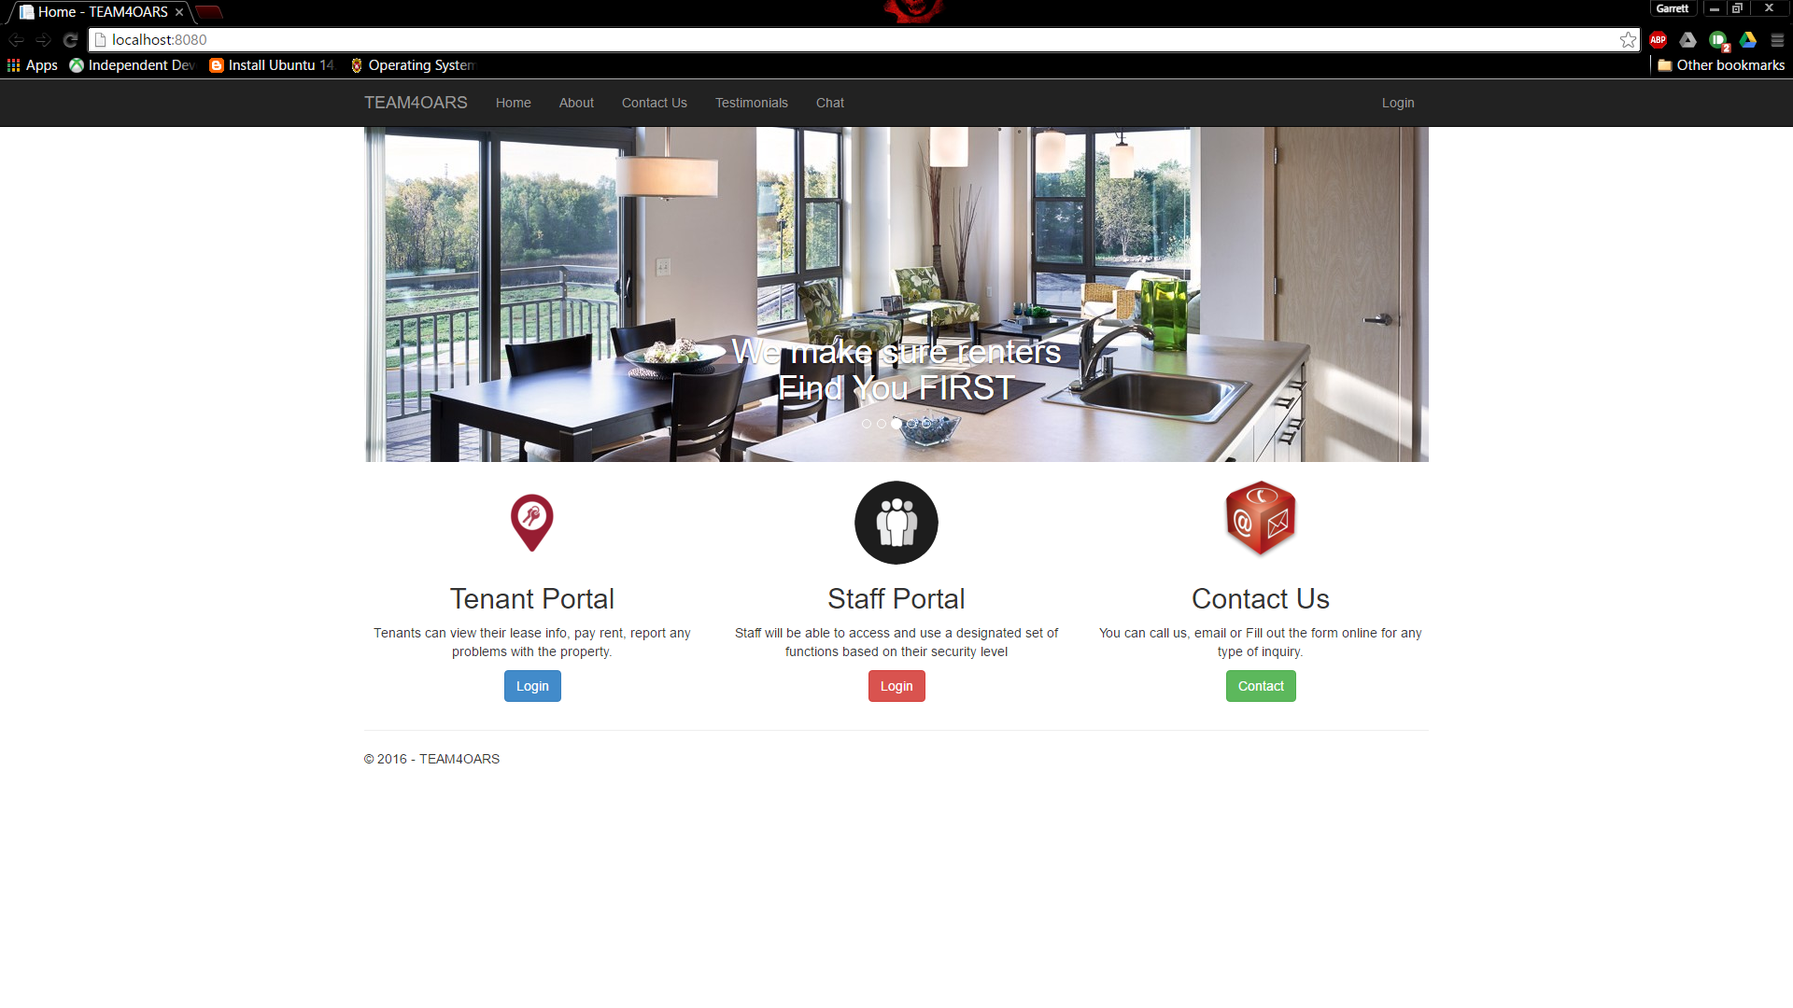

1. Login to TEAM4OARS (this account exists BEFORE A.T.)
Username: SUPERVISOR Password: SUPERVISOR #

2. Is the SUPERVISOR name and role displayed on the page? YES

3. Is the Apartment Rental Rates, Type and Amount displayed on the page? YES
SCREENSHOT after: 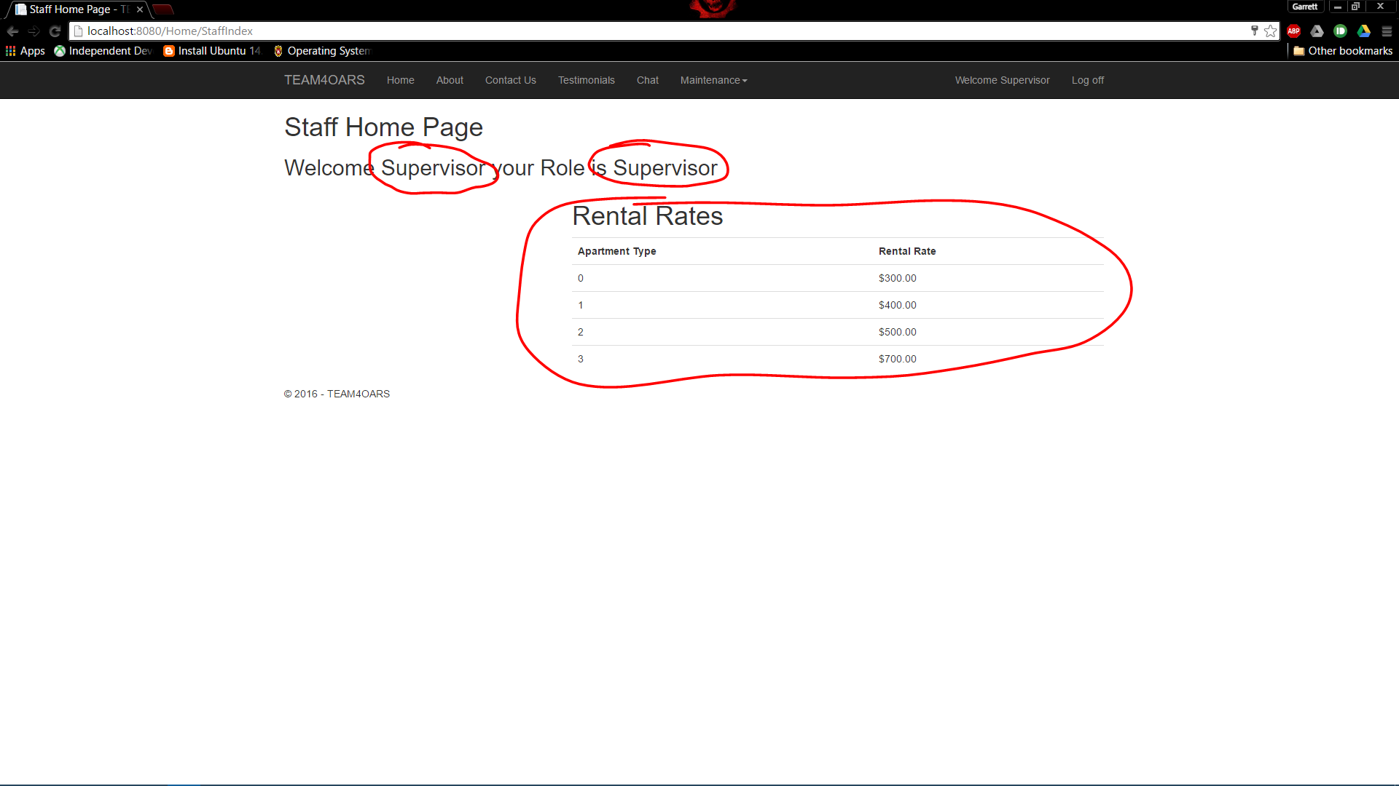
--------------------------------------------------------------------------------------------------------

SCREENSHOT before: 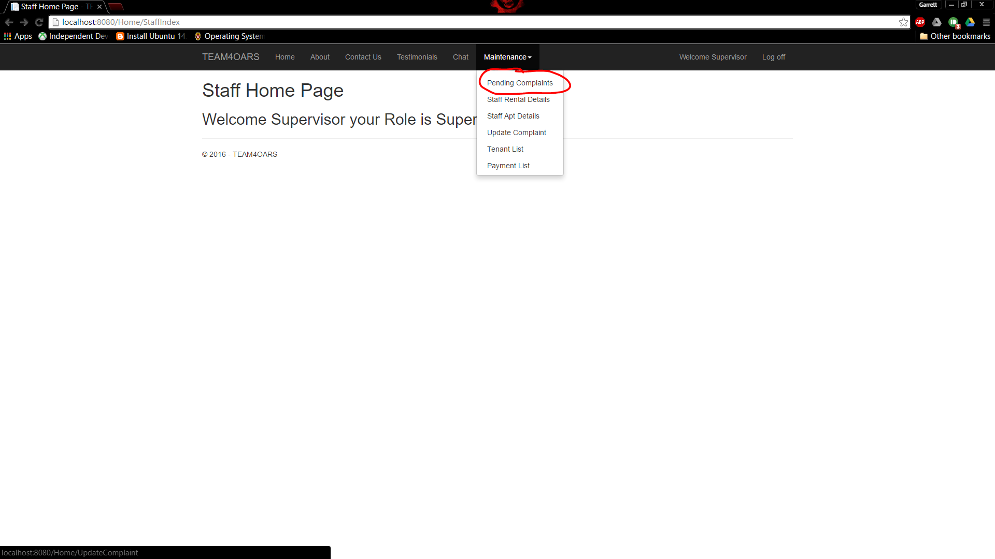

4. List Pending Apartment Complaints, Complaint#, Apartment#, Apartment Type, and Description.

SCREENSHOT after: 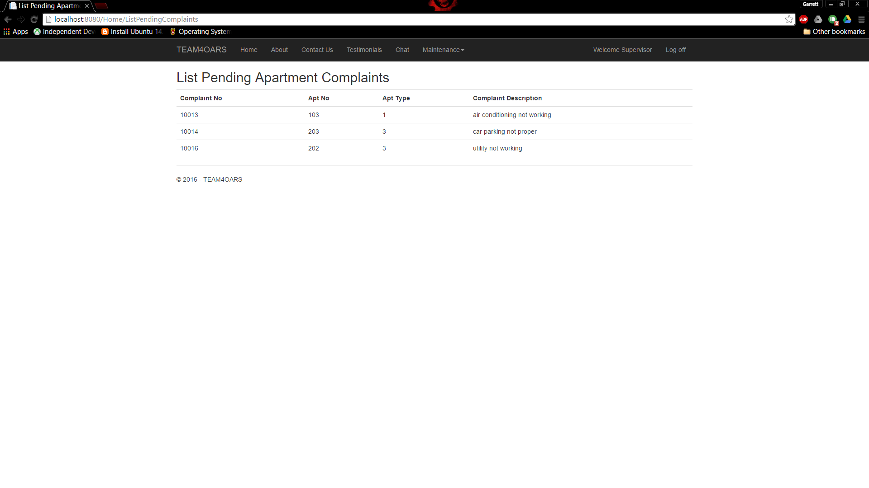
--------------------------------------------------------------------------------------------------------

SCREENSHOT before: 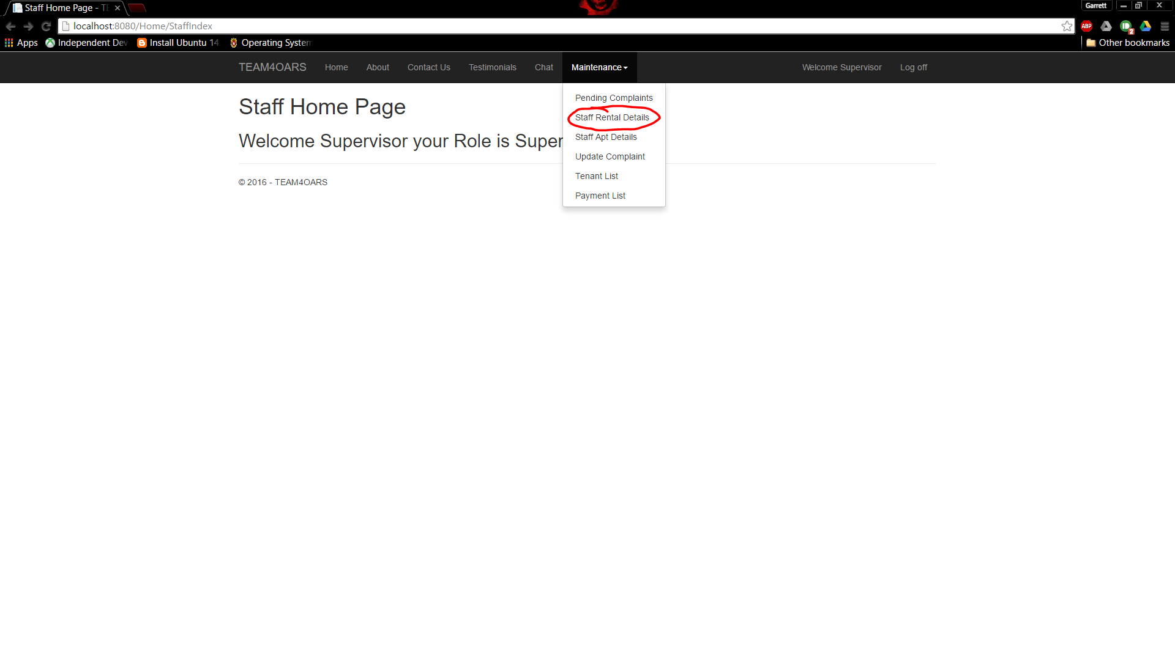

5. List Staff Rental Summary, Staff Name, Position, Number of Rentals.

SCREENSHOT after: 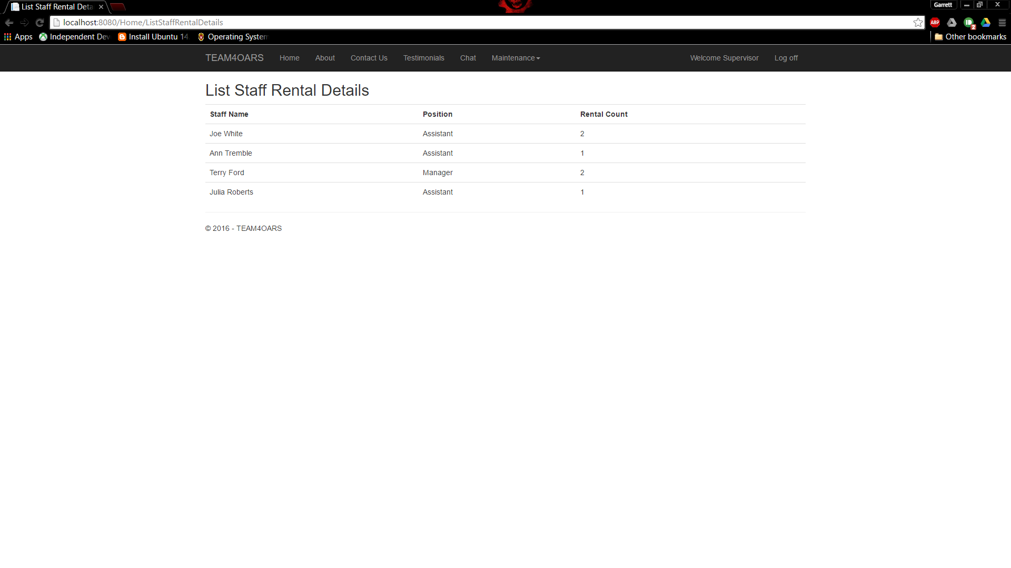
--------------------------------------------------------------------------------------------------------

SCREENSHOT before: 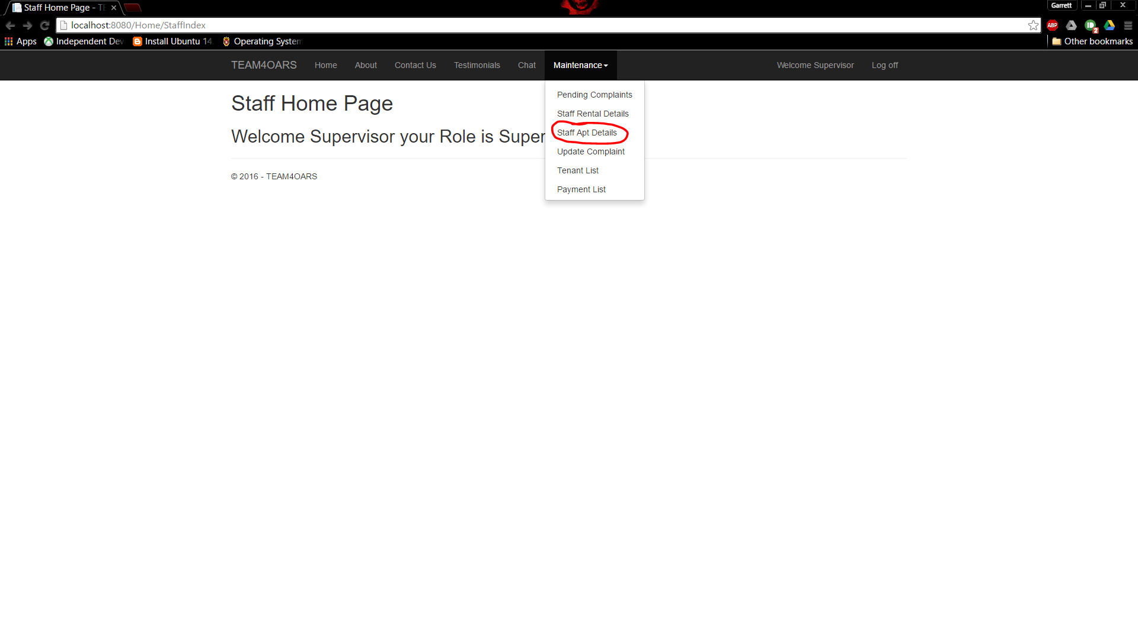

6. List Staff Apartment Details, First Name Last Name, Position, and a list of Apartments#.

SCREENSHOT after: 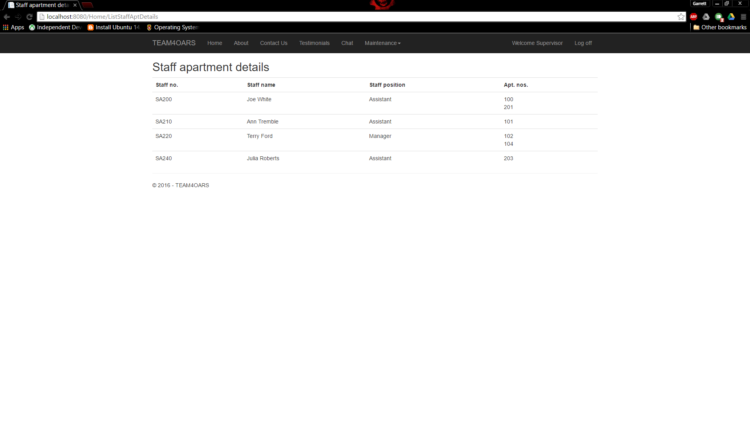

--------------------------------------------------------------------------------------------------------

SCREENSHOT before: 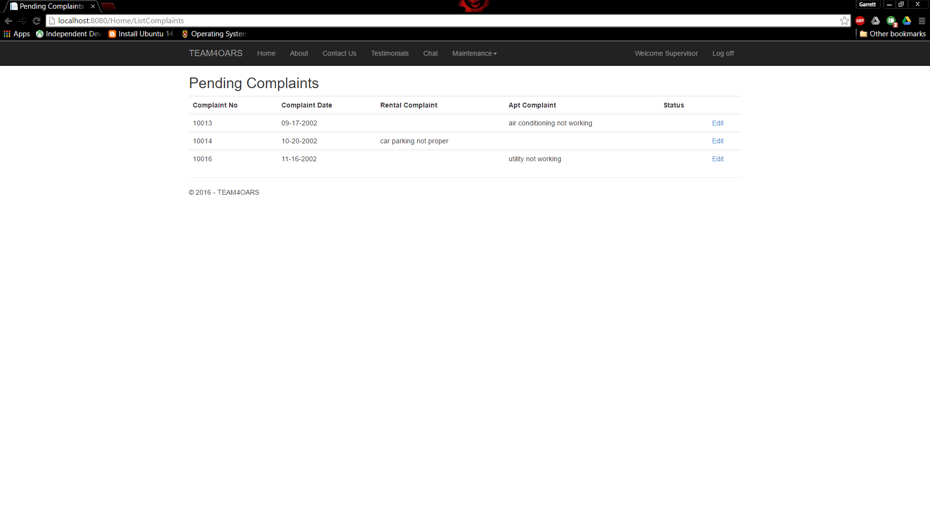

7. Update the status of Pending Complaints to Fix.

COMPLAINT_NO 10013 change STATUS to F

SCREENSHOT after: 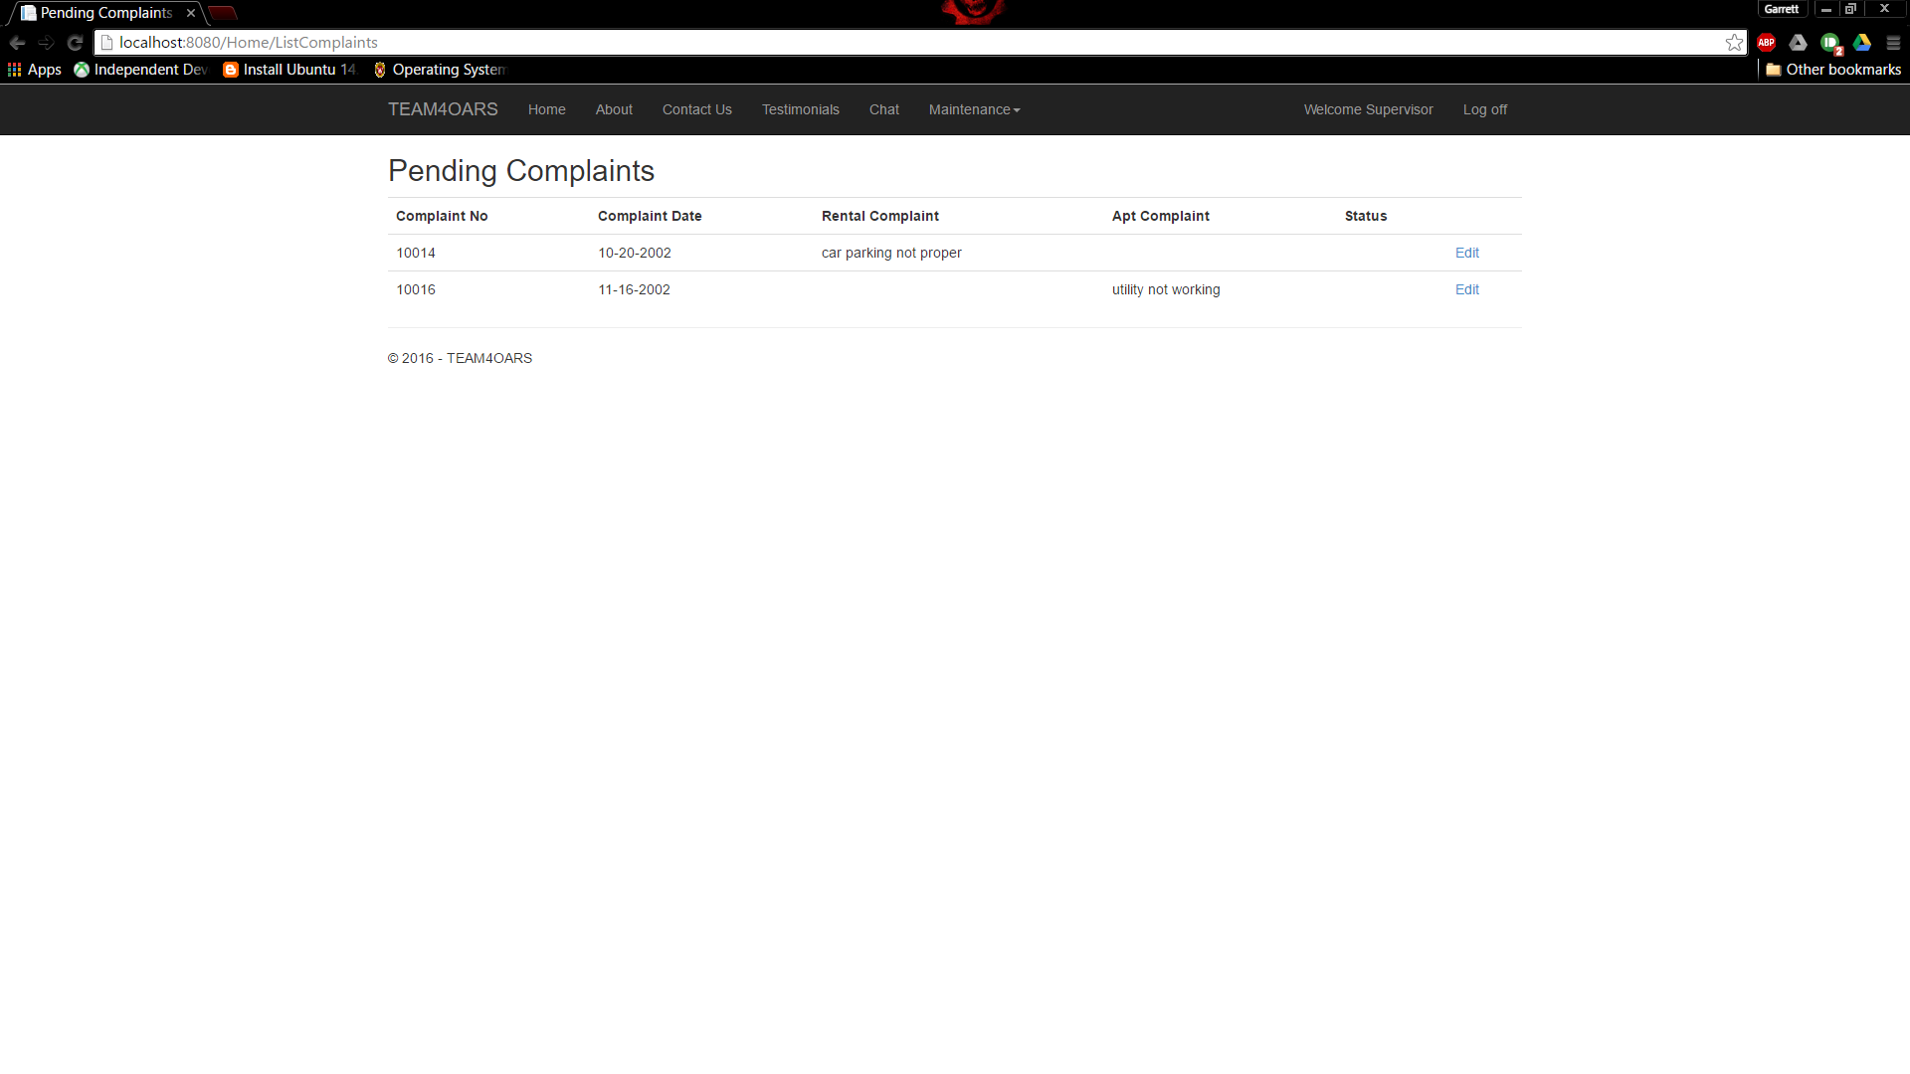
--------------------------------------------------------------------------------------------------------

SCREENSHOT before: 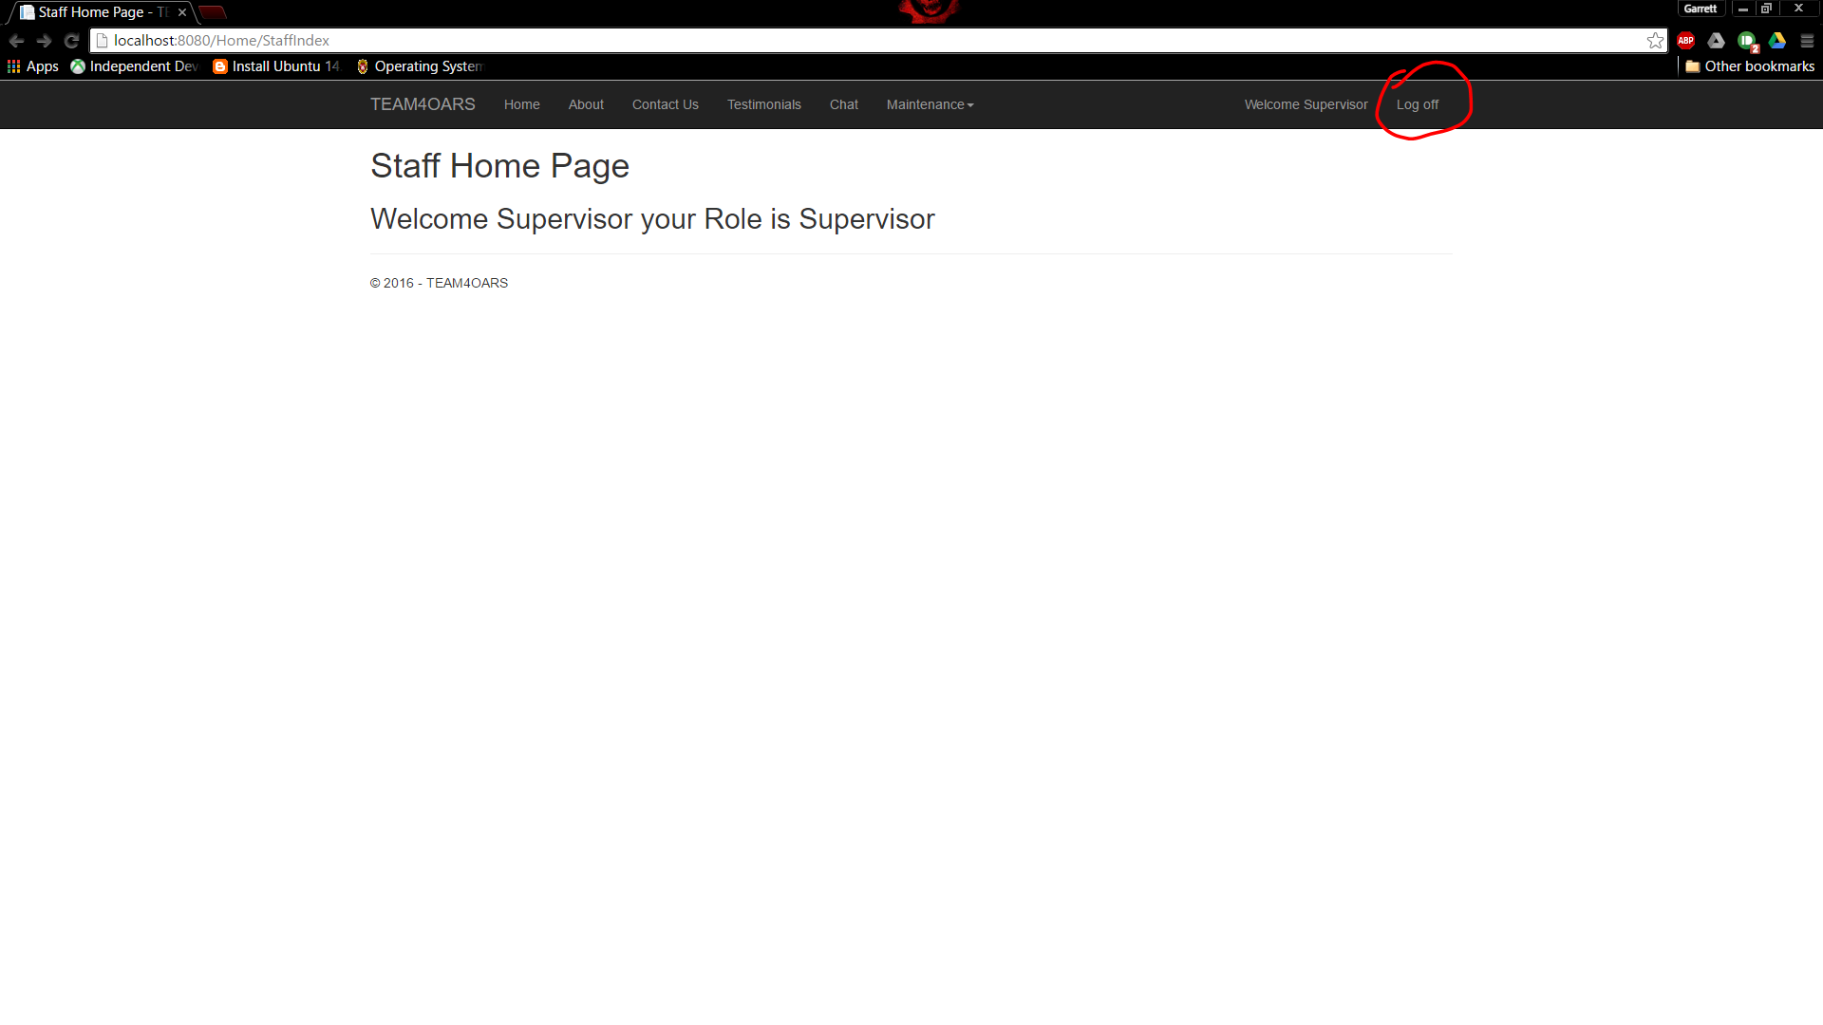

8. Logout

SCREENSHOT after: 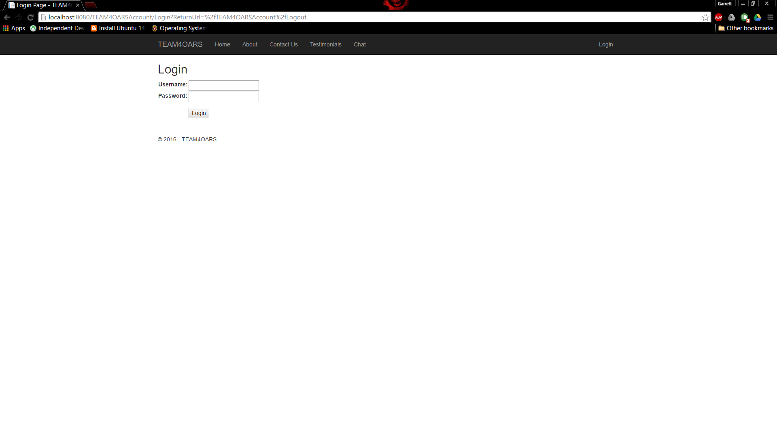

--------------------------------------------------------------------------------------------------------

Tenant
E

SCREENSHOT before:

1. Login to TEAM4OARS (this account exists BEFORE A.T.)
TENANT1 TENANT1 #

2. Is the TENANT1 name and role displayed on the page?

3. Is the TENANT1 SSN, NAME, DOB, MARITAL, WORK, HOME, EMPLOYER, GENDER displayed on the page?

4. Is the TENANT1 AUTO information, LICENSE NO, MAKE, MODEL, YEAR, and COLOR displayed on the page?

5. Is the TENANT1 FAMILY information (if applicable) FAMILY_SS, NAME, SPOUSE, CHILD, DIVORCED, SINGLE, GENDER, and DOB displayed on the page?

SCREENSHOT after:

--------------------------------------------------------------------------------------------------------

SCREENSHOT before:

6. Look up TENANT1 rental agreement with Rental Number, Rental Date, Apartment Number, Apartment Type, Apartment Deposit, Lease Type, Tenant SSN, Tenant Name, Tenant Work Number, and Tenant DOB.

SCREENSHOT after:

--------------------------------------------------------------------------------------------------------

SCREENSHOT before:

7. Pay Rent Input Form display Rental Number, and Credit Card Details Card Type, Card Number, Expiration Date, and Amount Charged ($500).

8. Are the Submit Payment and Clear displayed on the page?

SCREENSHOT after:

--------------------------------------------------------------------------------------------------------

SCREENSHOT before:

9. Is the Rent Receipt with the text “Rent Receipt” and TENANT NAME, TENANT SSN, RENTAL NO, APARTMENT NO, INVOICE NO, and RENT AMOUNT displayed on the page?

SCREENSHOT after:

--------------------------------------------------------------------------------------------------------

SCREENSHOT before:

10. Enter a Complaints “AC is not blowing cold air”.

SCREENSHOT after:

--------------------------------------------------------------------------------------------------------

SCREENSHOT before:

11. Enter a Testimonial “I think the TEAM?OARS web site is very user friendly”.

SCREENSHOT after:

--------------------------------------------------------------------------------------------------------

SCREENSHOT before:

12. Logout

SCREENSHOT after:

--------------------------------------------------------------------------------------------------------

New Tenant
F

SCREENSHOT before:

1. Register

TENANT_SS: 111 11 1111
TENANT_NAME: John Doe
TENANT_DOB: 4/25/70
MARITAL: S
WORK_PHONE: 111 111 1111
HOME_PHONE: 111 111 1111
EMPLOYER_NAME: UH
GENDER: M
USERNAME : TENANT6
PASSWORD : TENANT6#

SCREENSHOT after:

--------------------------------------------------------------------------------------------------------

SCREENSHOT before:

2. Login
TENANT6
TENANT6#

3. Is the Apartment Rental Rates, Type and Amount displayed on the page?

SCREENSHOT after:

--------------------------------------------------------------------------------------------------------

SCREENSHOT before:

4. Search TESTIMONIALS for keyword “TEAM4OARS”

SCREENSHOT after:

--------------------------------------------------------------------------------------------------------

ASSISTANT1 will log in and rent to the new Tenant in the next step.

Assistent1
G

SCREENSHOT before:

1. Login
ASSISTANT1 ASSISTENT1#

2. Is the ASSISTANT1 name and role displayed on the page?
3. Is the Apartment Rental Rates, Type and Amount displayed on the page?

SCREENSHOT after:
--------------------------------------------------------------------------------------------------------

SCREENSHOT before:

4. List the Apartment Available with four columns, a radio button that allows choosing an apartment, Apt NO, Apt TYPE, Deposit Amount ($400).

SCREENSHOT after:
--------------------------------------------------------------------------------------------------------

SCREENSHOT before:

5. Create Rental Input Form display Apt Number, Apt. Deposit, Lease Type, Tenant SSN, Tenant Name, Tenant Work, Tenant DOB.

SCREENSHOT after:
--------------------------------------------------------------------------------------------------------

SCREENSHOT before:

6. Is the Rental Confirmation Details with the text “Rental Confirmation Details” and Rental NO, RENTAL Date, RENT Deposit, text “Please Pay Rental Deposit Immediately”, and text “Thank you.” displayed on the page?

SCREENSHOT after:
--------------------------------------------------------------------------------------------------------

SCREENSHOT before:

7. Logout

SCREENSHOT after:

--------------------------------------------------------------------------------------------------------

SCREENSHOT before:

New Tenant

8. Look up TENANT6 rental agreement with Rental Number, Rental Date, Apartment Number, Apartment Type, Apartment Deposit, Lease Type, Tenant SSN, Tenant Name, Tenant Work Number, and Tenant DOB.

SCREENSHOT after:

--------------------------------------------------------------------------------------------------------

DBA
H

SCREENSHOT before:

1. DBA DISPLAYS the contents of the TENANT TABLE. (6 tuples; 10 columns)

SCREENSHOT after:

--------------------------------------------------------------------------------------------------------

SCREENSHOT before: 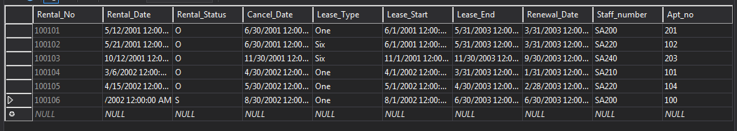

2. DBA DISPLAYS the contents of the RENTAL TABLE. (7 tuples; 10 columns)

SCREENSHOT after:

SCREENSHOT before: 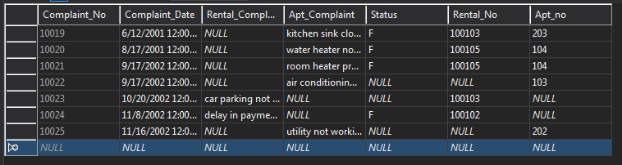

3. DBA DISPLAYS the contents of the COMPLAINTS TABLE. (8 tuples; 7 columns)

SCREENSHOT after:

--------------------------------------------------------------------------------------------------------

SCREENSHOT before:

4. DBA DISPLAYS the contents of the TESTIMONIAL TABLE. (4 tuples; 4 columns)

SCREENSHOT after:
--------------------------------------------------------------------------------------------------------

